Mike Colalillo Medal of Honor Scholarship
Supporting higher education in St. Louis County

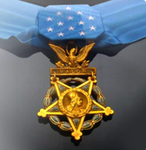
High school seniors and college students with a physical connection to St. Louis County, Minnesota, are encouraged to apply for the Mike Colalillo Medal of Honor Scholarship. The application deadline is Wednesday, September 12, 2021.
Mr. Colalillo was the last known surviving World War II Medal of Honor recipient in the State of Minnesota. He was born and raised in St. Louis County, and he dropped out of school when his mother died so he could help support the family. Following the war, Mr. Colalillo raised three children in Duluth, Minnesota. To learn about his military service, visit http://www.vets-hall.org/stories/world-war-ii/mike-colalillo.

Veterans Memorial Hall, a program of St. Louis County Historical Society, honors Mr. Colalillo by awarding annual scholarships to students who live in and/or go to school in St. Louis County, Minnesota.
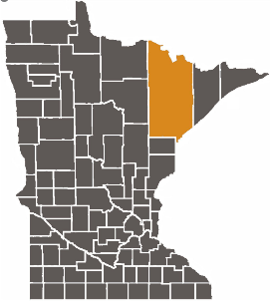
In 2021, a scholarship of $1,500 will be given to one student.
In order to be eligible, applicants must meet one of the following requirements:
SOURCE: http://www.mncourts.gov
- A full-time student who is enrolled in a higher education institution in St. Louis County, OR
- A resident of St. Louis County who is a full-time student enrolled in a higher education institution in another county or state, OR
- A high school senior who lives in St. Louis County and plans to attend a higher education institution
Scholarship applicants are required to submit a research paper on a topic relevant to veterans of St. Louis County, Minnesota. The paper must:
- Be a minimum of four (4) and a maximum of ten (10) double-spaced pages in length
- Address a historical event in St. Louis County, Minnesota, related to a conflict, a war or the home front; OR tell the story of a county veteran
- Include at least one source from the Albert J. Amatuzio Research Center, located in the St. Louis County Depot Building, 506 West Michigan Street, Duluth
- Include a bibliography
Staff members are available to answer questions, suggest possible research topics, and assist with the research. Please contact:
Jay Hagen, VMH Program Manager
218.733.7500
jay@thehistorypeople.org

Applications can be downloaded from the St. Louis County Historical Society website: https://www.thehistorypeople.org/news-and-resources.

Completed applications and research papers should be submitted to jay@thehistorypeople.org or mailed to:
Veterans Memorial Hall
506 West Michigan Street
Duluth, MN 55802
All submitted research papers will become the property of Veterans Memorial Hall/St. Louis County Historical Society. The Society reserves the right to publish the paper on its website with no additional remuneration.

The Mike Colalillo Medal of Honor Scholarship Fund is fiscally administered by the Duluth Superior Area Community Foundation.
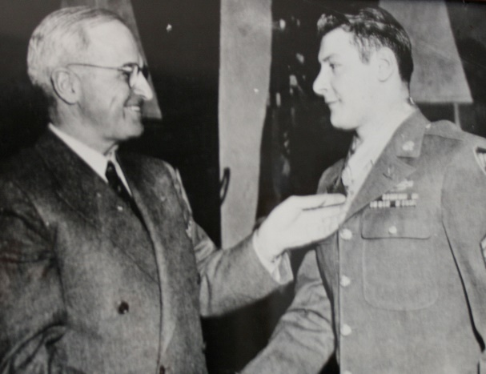
To make a donation to the scholarship fund, make your check payable to the Duluth Superior Area Community Foundation. Please specify that the donation is designated for the Mike Colalillo Scholarship Fund and mail to:

Duluth Superior Area Community Foundation
324 West Superior Street, Suite 700
Duluth, MN, 55802

Online donations may be made at:
http://www.dsacommunityfoundation.com/mike-colalillo-medal-of-honor-scholarship-fund.

2021 Mike Colalillo Medal of Honor
Scholarship Application
The 2021 application deadline is Wednesday, September 15, 2021.

Applicant status as of the Fall Semester 2021 (check one)

☐ High School Senior ☐ College Freshman ☐ College Sophomore
☐ College Junior ☐ College Senior

Applicant’s Full Name: Click here to enter text.

Mailing address:

Street: Click here to enter text.

City: Click here to enter text. State: Zip: Click here to enter text.

If temporary, add permanent address:

Street: Click here to enter text.

City: Click here to enter text. State: Zip: Click here to enter text.

E-mail address: Click here to enter text. Phone: Click here to enter text.

Date of birth: Click here to enter a date. Place of birth: Click here to enter text.

Higher Education Institution: Click here to enter text.

Street: Click here to enter text.

City: Click here to enter text. State: Zip: Click here to enter text.

Academic Advisor: Click here to enter text.

E-mail address: Click here to enter text. Phone: Click here to enter text.

I have read the eligibility requirements (on the reverse), I am eligible to participate, and I agree to the terms. In addition, I am aware that the research paper will become the property of the St. Louis County Historical Society and may be published online.

Applicant signature: _________________________________Date: Click here to enter a date.

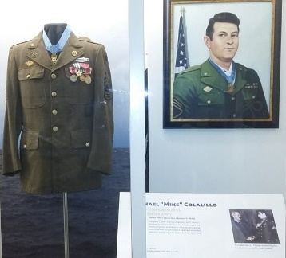

Return applications to:
St. Louis County Historical Society
Veterans Memorial Hall Program
506 Michigan Street
Duluth, MN 55802
Or electronically by email to the staff members below.

Eligibility Criteria

In order to be eligible, applicants must meet one of the following requirements:
- A full-time student who is enrolled in a higher education institution in St. Louis County, OR
- A resident of St. Louis County who is a full-time student enrolled in a higher education institution in another county or state, OR
- A high school senior who lives in St. Louis County and plans to attend a higher education institution

Application Requirement
Scholarship applicants are required to submit a research paper on a topic relevant to veterans of St. Louis County, Minnesota. The paper must:
- Address a historical event in St. Louis County, Minnesota, related to a conflict, a war or the home front; OR tell the story of a county veteran
- Be a minimum of four (4) and a maximum of ten (10) double-spaced pages in length
- Include at least one source from the Albert J. Amatuzio Research Center, located in at:
  - St. Louis County Depot Building,
  - 506 West Michigan Street, Duluth, MN 55802
- Include a bibliography

Staff members are available to answer questions, suggest possible research topics, and assist with the research from 10 a.m. – 3 p.m., Monday – Friday. Please contact:
Jay Hagen, VMH Program Manager
218.733.7500
jay@thehistorypeople.org

For more information, please visit the St. Louis County Historical Society website:
Mike Colalillo Medal of Honor Scholarship (thehistorypeople.org).

The research paper will become the property of the Veterans Memorial Hall Program/St. Louis County Historical Society. The Society reserves the right to publish the paper on its website with no additional remuneration.

